EXPERIMENT 5b – DATA VISUALIZATION USING MATPLOTLIB

Aim
To create and analyze different types of data visualizations using Python and Matplotlib, including line charts, bar charts, pie charts, and histograms.

Algorithm
Step 1: Import the required library, Matplotlib.
Step 2: Create data for monthly sales using months and sales values.
Step 3: Create a line plot to visualize the monthly sales trend.
Step 4: Create a bar chart to compare sales across different months.
Step 5: Create data representing the number of employees in different departments.
Step 6: Create a pie chart to visualize the percentage distribution of employees across departments.
Step 7: Create a dataset containing student marks.
Step 8: Create a histogram to visualize the distribution of marks.
Step 9: Add appropriate titles and labels to all visualizations.
Step 10: Display all the generated charts using plt.show().

Program

1. Line Plot – Monthly Sales
import matplotlib.pyplot as plt
months = ["Jan", "Feb", "Mar", "Apr", "May", "Jun"]sales = [120, 150, 180, 170, 220, 250]
plt.plot(months, sales)
plt.title("Monthly Sales")plt.xlabel("Months")plt.ylabel("Sales")
plt.show()

2. Bar Chart – Monthly Sales
import matplotlib.pyplot as plt
months = ["Jan", "Feb", "Mar", "Apr", "May", "Jun"]sales = [120, 150, 180, 170, 220, 250]
plt.bar(months, sales)
plt.title("Monthly Sales")plt.xlabel("Months")plt.ylabel("Sales")
plt.show()

3. Pie Chart – Employee Distribution
import matplotlib.pyplot as plt
departments = ["HR", "IT", "Finance", "Sales"]employees = [25, 40, 20, 15]
plt.pie(
employees,
labels=departments,
autopct="%1.1f%%"
)
plt.title("Employee Distribution")
plt.show()

4. Histogram – Distribution of Marks
import matplotlib.pyplot as plt
marks = [
45, 50, 55, 60, 62, 65, 68, 70, 72,
75, 78, 80, 82, 85, 88, 90, 92, 95
]
plt.hist(marks, bins=5)
plt.title("Distribution of Marks")plt.xlabel("Marks")plt.ylabel("Frequency")
plt.show()

Output:
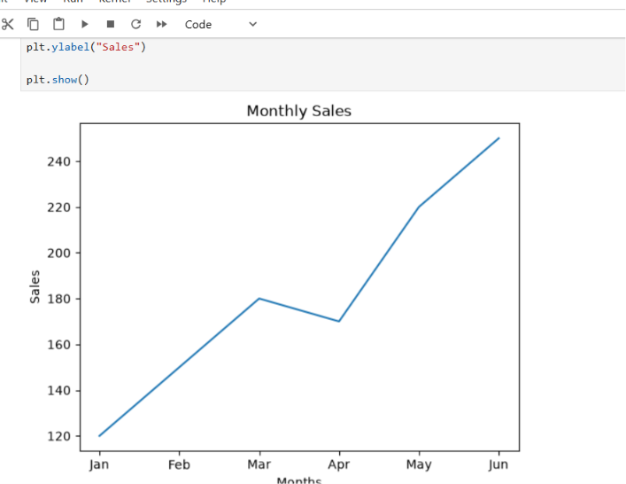
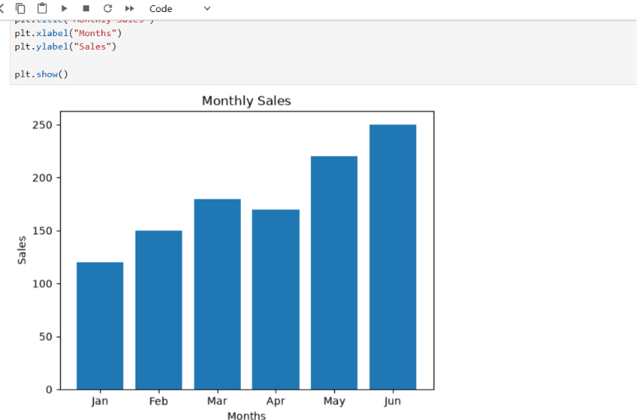
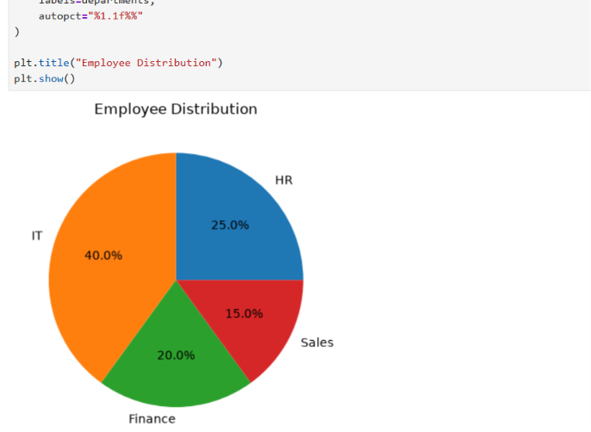

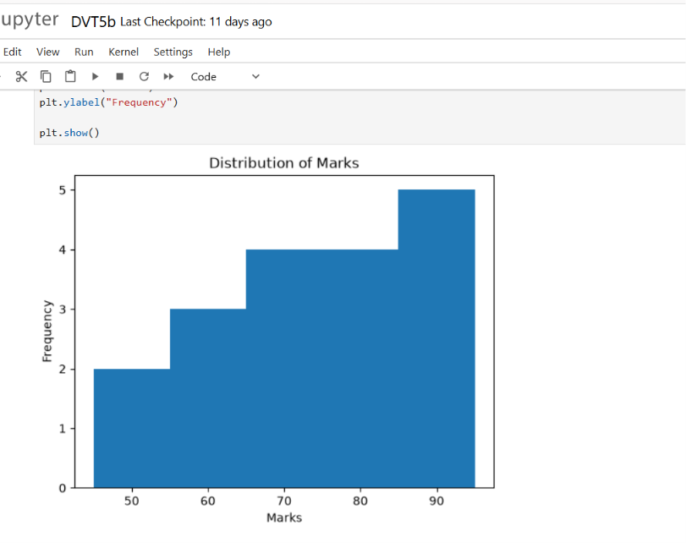
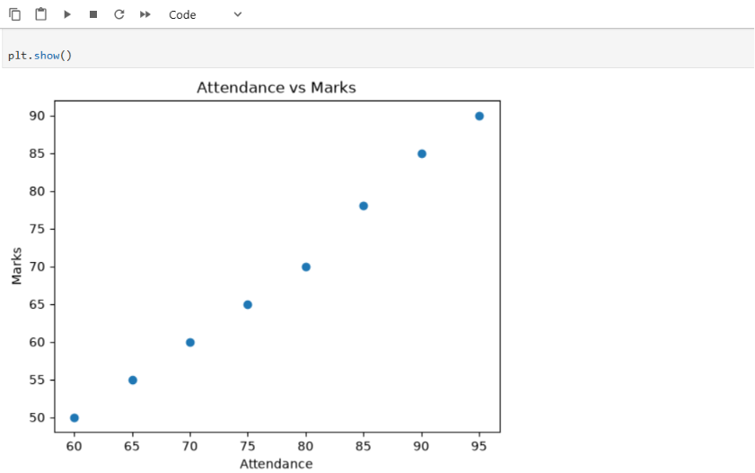
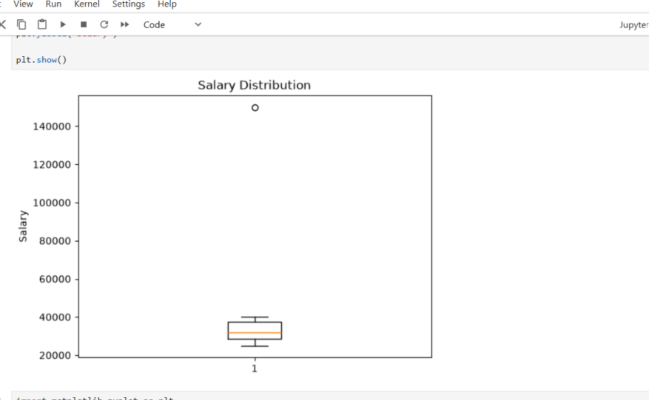
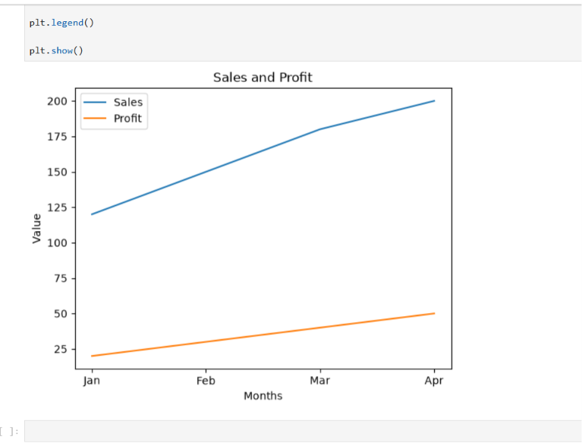

Result
Thus, different types of data visualizations were successfully created using Matplotlib in Python. The line plot was used to show the sales trend, the bar chart was used to compare monthly sales, the pie chart was used to represent employee distribution, and the histogram was used to analyze the distribution of student marks.

